Information System Security Plan
- Information System Name/Title:
- Civilian Federal Agency Human Resources Information System (HRIS)
- CFA-HRIS-001
- Information System Categorization:
- {(Confidentiality, Moderate), (Integrity, Moderate), (Availability, Moderate)}
- Overall System Security Impact Level: Moderate
  - Confidentiality Impact Level: Moderate
    - Unauthorized disclosure of employee PII, payroll data, or benefits information could result in identity theft, financial harm to individuals, reputational damage to the agency, and regulatory consequences under federal privacy requirements. The adverse effect would be serious but not catastrophic.
  - Integrity Impact Level: Moderate
    - Unauthorized modification or corruption of HR data, including payroll, employment status, or benefits records, could result in improper compensation, legal disputes, operational disruption, and loss of trust in agency administrative functions. The adverse effect would be serious but not catastrophic.
  - Availability Impact Level: Moderate
    - Loss of system availability would disrupt payroll processing, benefits administration, and HR operations. Although short-term outages may be manageable through manual processes, extended downtime would significantly affect agency operations and employee services. The adverse effect would be serious but not catastrophic.
- Impact if the System Failed:
  - Payroll disruption, including delayed or inaccurate employee compensation
  - Errors in benefits administration and employment records
  - Increased manual processing and higher administrative burden
  - Loss of data availability affecting HR operations and employee self-service
  - Compliance violations related to payroll, tax reporting, or employee data protection
  - Financial loss and potential legal exposure
  - Reputational damage and reduced employee trust in organizational systems
- Information Types Processed
  - The HRIS processes and stores federal employee personnel records, including personally identifiable information (PII), payroll information, employment status data, and benefits enrollment information. The system supports administrative human resources functions for a civilian federal agency.
- Information System Owner:
Sarah Mitchell
Director of Human Resources Systems
Civilian Federal Agency
sarah.mitchell@cfa.gov
(202) 555-0134
- Authorizing Official:
James Carter
Chief Information Officer
Civilian Federal Agency
james.carter@cfa.gov
(202) 555-0110
- Other Designated Contacts:
Michael Reyes
Information System Security Officer (ISSO)
Civilian Federal Agency
michael.reyes@cfa.gov
(202) 555-0142
Lisa Nguyen
Agency Privacy Officer
Civilian Federal Agency
lisa.nguyen@cfa.gov
(202) 555-0168
- Information System Operational Status:
 | Operational | X | Under Development |  | Major Modification
- Information System Type:
X | Major Application |  | General Support System
- General System Description/Purpose:
The Human Resources Information System (HRIS) is a Software as a Service (SaaS) major application that centralizes and automates core human resources functions for the Civilian Federal Agency. The system supports personnel management activities including onboarding and offboarding, time and attendance tracking, benefits administration, employee records management, reporting and analytics, and integration with external payroll services. The HRIS enables authorized personnel to manage workforce data while providing employees and supervisors with self-service capabilities in accordance with agency policies.
Business Functions Supported:
- Recruiting and onboarding
- Employee records management
- Benefits enrollment and administration
- Time and attendance tracking
- Performance reviews and training tracking
- HR analytics and compliance tracking
- Payroll coordination through integration with an external payroll provider or finance system
Data Types Processed:
- Personally identifiable information including name, address, phone number, email, and date of birth
- Employment data including employee ID, job title, manager, location, status, and salary band
- Benefits data including plan selections, dependents, and eligibility dates
- Time and attendance data including work schedules, timecards, and leave balances
- Sensitive data depending on organizational requirements such as SSN, bank information, tax forms, and emergency contacts
Users and Roles
- HR Administrator – Full access to HR records and system configuration settings.
- HR Specialist – Responsible for onboarding, benefits administration, and employee data changes.
- Manager or Supervisor – Access to direct report information and approval functions.
- Employee – Limited access to personal information and self-service functions.
- Finance or Payroll Staff – Access to payroll coordination data and reporting interfaces.
- Auditor or Compliance Viewer – Read-only access to reports and audit logs for oversight purposes.
- System Environment
- SaaS cloud hosted HRIS operated by a third-party vendor
  - SaaS (Software as a Service): A company that hosts an application and makes it available to customers over the internet
- Accessed through web browsers from organization managed endpoints and approved personal devices
- Integrated with enterprise Single Sign On (SSO) and Multi Factor Authentication (MFA) for secure authentication
- Secured API connections supporting data exchange with payroll and benefits systems
- System Boundary
Authorizing Boundary:
The authorization boundary for the HRIS includes the organization's HRIS SaaS tenant and the configurations managed by the agency within the application. This includes user role configuration, access control settings, audit logging settings, and HR data stored within the HRIS application.

The authorization boundary does not include the underlying cloud infrastructure used to host the system. Infrastructure components such as servers, storage, networking, virtualization, and physical hosting are managed by the SaaS provider and are outside of the agency's authorization boundary.

External systems that exchange information with the HRIS, such as payroll and benefits providers, are considered interconnected systems and are not included within the HRIS authorization boundary.
Inside the Boundary:
- HRIS application and database
- User authentication and access control mechanisms
- Organization’s HRIS SaaS tenant configuration and managed settings
- Audit logs and system configuration settings
- Data interfaces used to import and export HR related data
Outside the Boundary:
- External payroll provider system
- Banking and tax filing systems
- External benefits providers
- External background check vendor systems
- Email and collaboration tools used for notifications
- Underlying cloud infrastructure managed by the SaaS vendor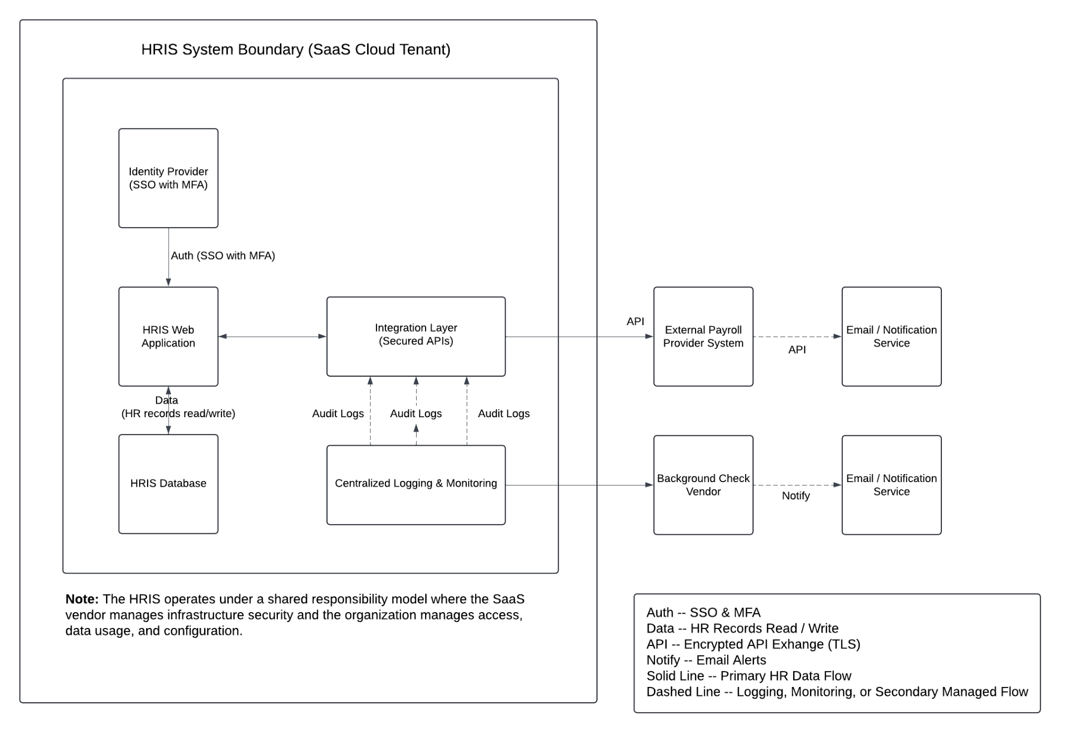
- System Interconnections
The HRIS exchanges information with several external systems through secured API connections to support payroll processing, background checks, and notification services. These systems operate outside the HRIS authorization boundary and are considered interconnected systems.
External System | Purpose | Data Exchanged
Enterprise Identity Provider | Authentication and identity federation | User authentication assertions
External Payroll Provider | Payroll processing and financial coordination | Employee compensation data, payroll deductions, tax withholdings
Background Check Vendor | Employment verification services | Employee identification and verification data
Email Notification Service | System notifications and alerts | System generated notification messages

- Shared Responsibility Considerations
The HRIS operates as a Software as a Service solution. The vendor manages physical infrastructure, database engine maintenance, platform availability, and underlying security controls. The organization retains responsibility for tenant configuration, access management, data protection, monitoring, and regulatory compliance. Risks identified within this project focus on areas under organizational control.
- Core Components
- HRIS web application includes administrative and employee self-service portal
- Database storing HR records and transactions
- Identity and access control integrated with enterprise SSO and MFA enforcement
- Reporting and analytics module
- An integration layer utilizing secured APIs is used to exchange HR data with external systems such as payroll and benefits providers
- Logging and monitoring capabilities
- Minimum Security Controls:
Security controls for the HRIS are derived from the NIST SP 800-53 Moderate baseline and were tailored based on system architecture and shared responsibility considerations. A representative subset of controls documenting implementation descriptions, scoping guidance, and responsible parties is provided in Appendix A.
- Information System Security Plan Completion Date: 08 March 2026
- Information System Security Plan Approval Date: 15 March 2026

